1. A short overview of how you would test the API. It can in the form of a short test plan but the format is up to you.  
  
**Answer:** I will use Postman tools to test the API request by using following steps -

* I would create a base URL to avoid rewriting the URL.
* I would add different requests get, put, patch, delete according to the project requirement, put the request endpoints after base URL, add content in the body for post, patch requests, add authentication key in the header’s value field, and them simply send them.
* After sending request I would write test for the response and very the responses according to the requirements.

2. A set of automated tests using your chosen test automation tool. Instructions on how to run the test suite should be provided.

**Answer:**

Since I have chosen Postman tool the write the test. Here the steps below will show how someone can run and test this project -

Step 1 --- Download and Install postman: (<https://www.postman.com/downloads/>)

Step 2 --- Signup and login to Postman

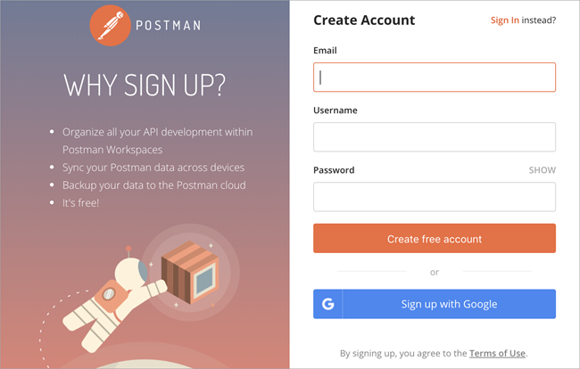

Step 3 --- Open the Postman application

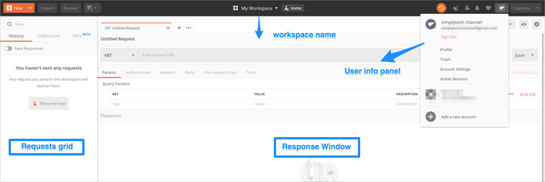

Step 4 --- Create a new request

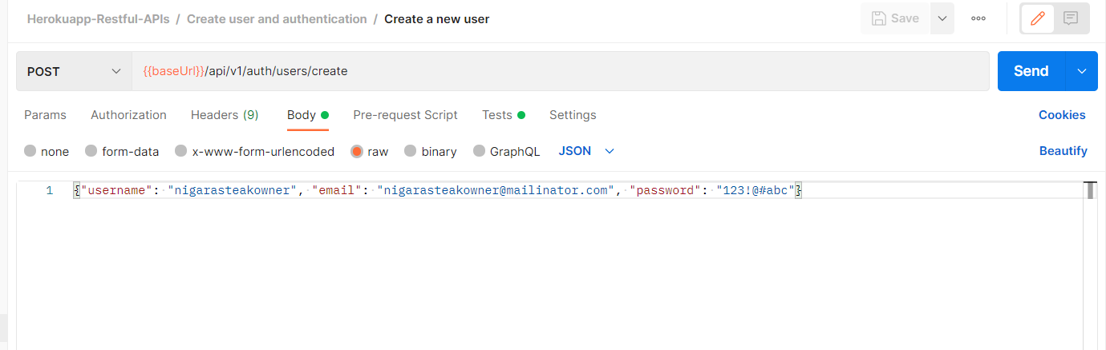

Step 5 --- Send when done

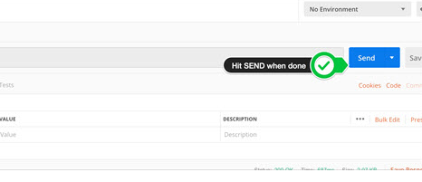

Step 6 --- Run collection from postman

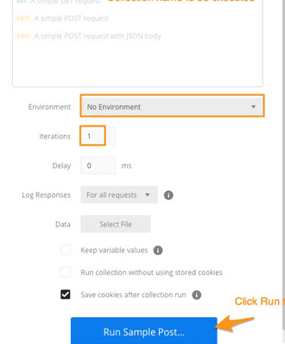

Step 7 --- If you collection file you can import the collection and Run

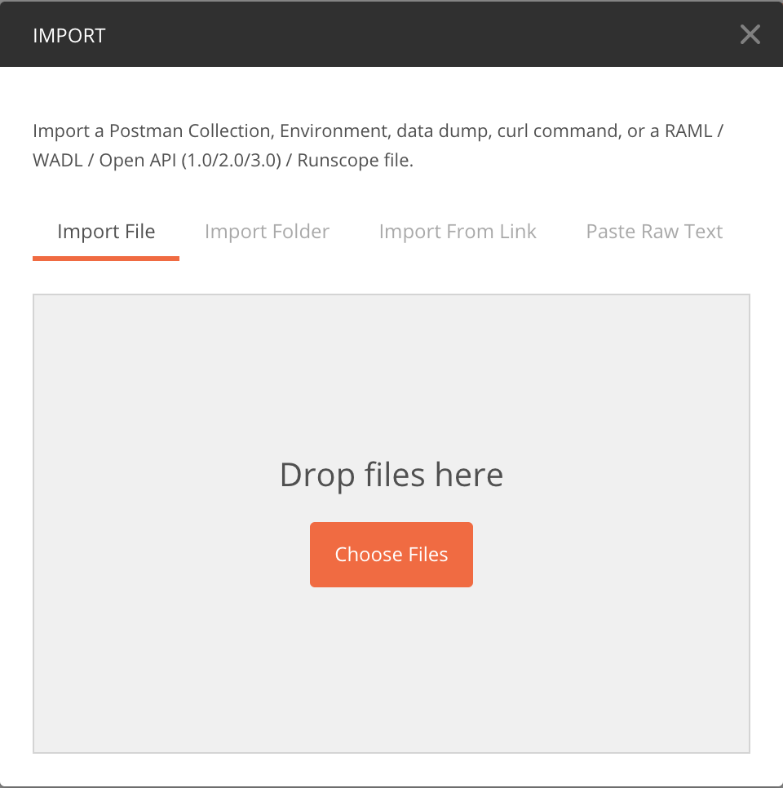

Step 8 --- Export Collection

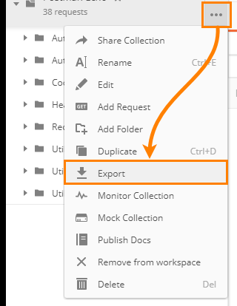

**For adding authorization:**

> Click on Headers >Put an authorization name >Put authorization key in the ‘Value’ field

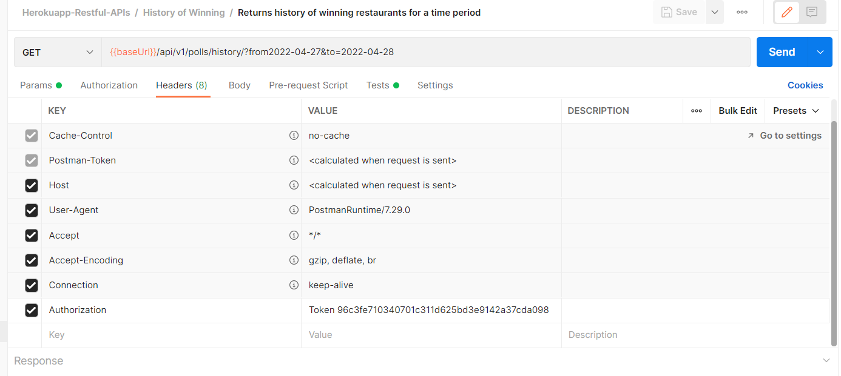

3. If automation isn't suitable for some cases or you'd prefer to test them manually, please describe those test cases.

**Answer:** I would simply test the responses manually according to the requirements like testing response code, headers type, body area. Would compare with the expected results.

4. Provide a list of defects found. A text document is sufficient.